HPC Project Report
Accelerating KLT Algorithm
Version 1.0: Profiling
M. Abdullah Siddiqui | 23I-0617
M. Daniyal | 23I-0579
Moiz Ansari | 23I-0523

Introduction
This version is focused on the profiling of the KLT algorithm, identifying the hotspots and understanding the theoretical performance that can be achieved with the acceleration. Following are the steps taken for profiling:
- Choosing the profiler
- Executing the code
- Profiling details
- Understanding the profiling details
- Identifying GPU-Suitable Functions
- Theoretical performance measurement using Amdahl’s Law
Now we will explore these in detail.

Initial Steps

Choosing the Profiler
For c++ code files, we had many options for profilers. However, the profiler we chose is “gprof” as it natively comes with gcc and requires minimal setup. We already had the makefile for the execution of the code. This makefile was altered to include the gprof compatible commands for code profiling.

Executing the Code
The code was executed by running the makefile we made in the above step. It was noted that there were 5 examples. However, only example 3 was run as instructed in the project requirements. It produced executables as well as gmon.out.

Profiling Details
Example 3 was successfully executed in the above step. Finally, a gmon.out binary file was generated that will be used for profiling the code.

Understanding the Profiling Details

Tabular Format
The gmon.out was a binary file which cannot be directly read. A gprof command was run to convert the binary file to a text file. Later, the text file contained all the necessary details (code profile) of the functions, their computation times, cumulative times, etc.

Graphical Format
Though we had the tabular format, yet data analysis is a bit difficult.
We had a .sh bash script that reads the text file (generated above), calls the .py script which then converts it into a graphical format.
We had a .py script that converts the data to a .dot file which the Dot command uses to convert it into a graphical format using GraphViz. The resulting graph made it easy to understand the hierarchy of functions and their calling patterns. Along with that we got the percentages of the amount of computation each function is performing.

Identifying GPU-Suitable Functions
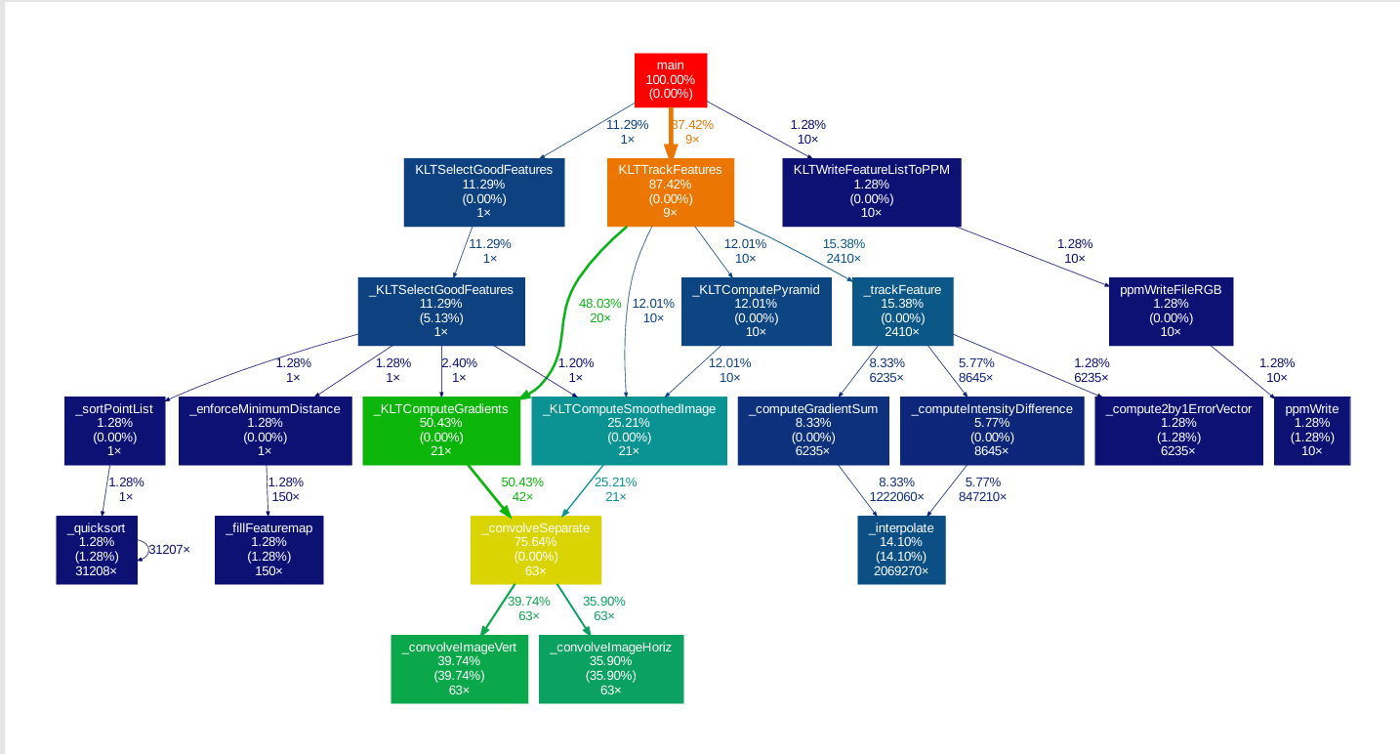
According to the profiling data, three functions are suitable candidates for GPU acceleration:
- _convolveImageVert() - 39.74% of runtime
- _convolveImageHoriz() - 35.90% of runtime
- _interpolate() - 14.10% of runtime Combined, these represent 89.74% of total execution time.
These three functions are chosen based on their ability of being parallelized on the GPU that is no dependency.

Theoretical performance measurement using Amdahl’s law

Single functions: (∞ speedup)
1. Only _convolveImageVert
P = 0.3974 => Speedup = 1 / (1 - 0.3974) = 1 / 0.6026 = 1.66×
2. Only _convolveImageHoriz
P = 0.3590 => Speedup = 1 / (1 - 0.3590) = 1 / 0.6410 = 1.56×
3. Only _interpolate
P = 0.1410 => Speedup = 1 / (1 - 0.1410) = 1 / 0.8590= 1.16×

Two Functions: (∞ speedup each)
4. Both Convolutions
P = 0.3974 + 0.3590 = 0.7564 => Speedup = 1 / (1 - 0.7564) = 1 / 0.2436 = 4.11×
5. _convolveImageVert + _interpolate
P = 0.3974 + 0.1410 = 0.5384 => Speedup = 1 / (1 - 0.5384) = 1 / 0.4616 = 2.17×
6. _convolveImageHoriz + _interpolate
P = 0.3590 + 0.1410 = 0.5000 => Speedup = 1 / (1 - 0.5000) = 1 / 0.5000 = 2.00×

All Three Functions: (∞ speedup)
7. All Three Functions
P = 0.3974 + 0.3590 + 0.1410 = 0.8974 => Speedup = 1 / (1 - 0.8974) = 1 / 0.1026 = 9.75×

So in conclusion if we shift all three functions to GPU it will theoretically increase our performance 9.75x.

GitHub Private Repository Link
https://github.com/MuhammaDaniyal/Complex_Computing_Problem

